If you are interested in being baptised or in having a child baptised I would be pleased to meet with you and talk about it. I would like to make that as meaningful an occasion as possible for you and your family. Get in touch and I will come and meet you. In the meantime, let me explain a few things to help you think about it

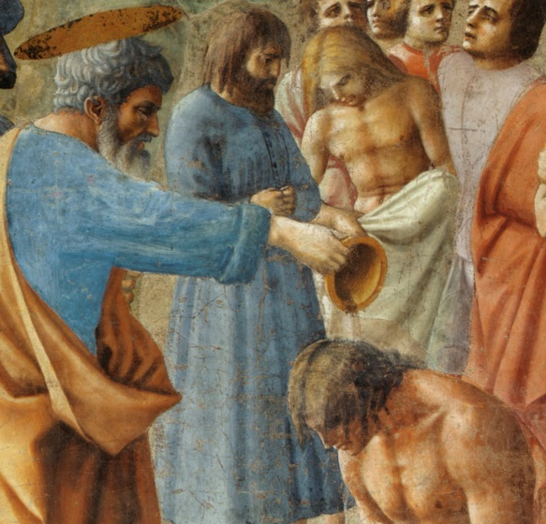
Baptism - what is required?

Baptism is a sign of participation in fellowship with Jesus and with his church. In the Bible, people who turned to God in faith and received Jesus as their Lord were baptised as a sign of their belonging to the people of Jesus.

We believe it is right to also baptise the children of those who are followers of Jesus. When children are baptised the parents will promise to nurture the child in the Christian Faith.

So it is a requirement of the Church of Scotland that at least on parent be a church member (or otherwise a regular participant in worship) or intending to become a church member. Alternatively, another family member (such as an uncle or grandparent) who is a church member may ‘sponsor’ the child by taking responsibility for the child’s Christian nurture.

The Church?

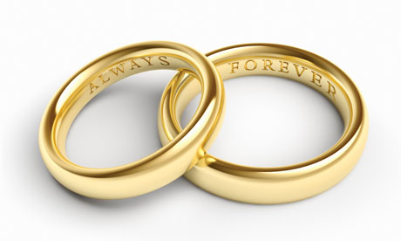
Christianity is something we work at together and baptism belongs in the context of a group of Christians - a church. Of course belonging to the church is not the same thing as being a Christian, just as living in the same house as someone doesn't make you their husband or partner! The essential thing in either is your personal relationship.

When an adult says "I'm going to follow Jesus" and gets baptised it’s a bit like putting on a wedding ring - a symbol of belonging forever. The relationship is the main thing. The water is just a symbol.

‘Belonging forever’…?

What makes Christianity distinctive is the offer of ‘grace’- the free offer of acceptance and a relationship with God.
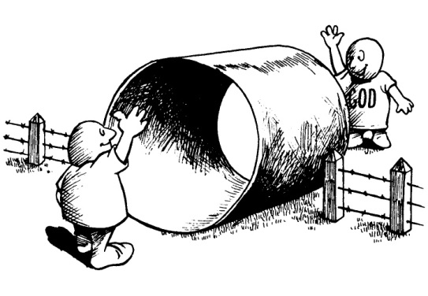
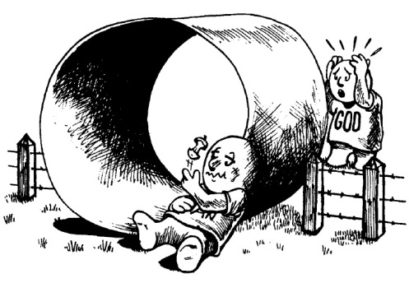
We believe God made human beings for a relationship with himself - creature and creator like children and a father.
Human wilfulness has spoiled that relationship (as in the
story of Adam and Eve).
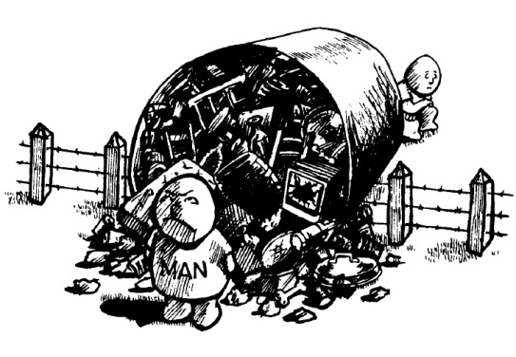
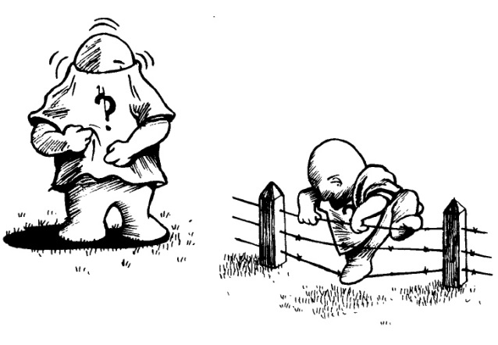
Selfishness is natural to all of us and has separated us from God in this life and in eternity.

But God, who made human beings for himself has done an
indescribably wonderful thing;
He has become one of us - born as Jesus of Nazareth.
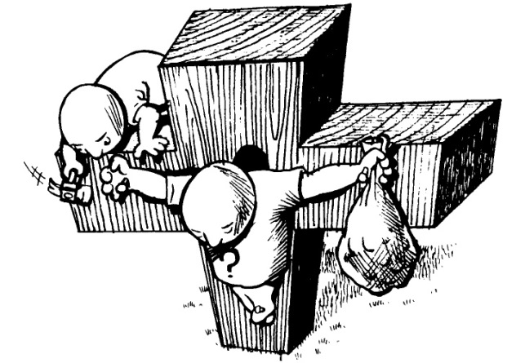
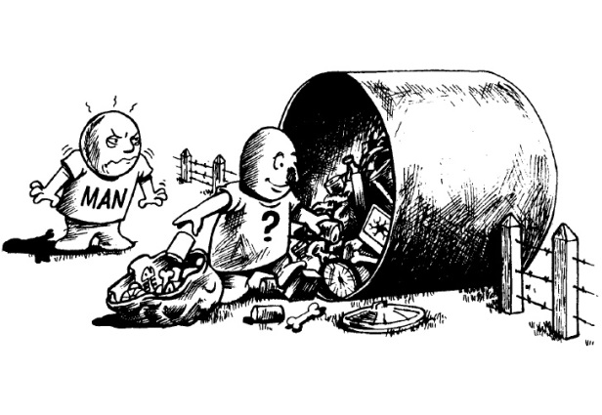

Jesus was crucified, as a human being, for the rubbish in human lives. He carried our sins and defeated the curse of death.

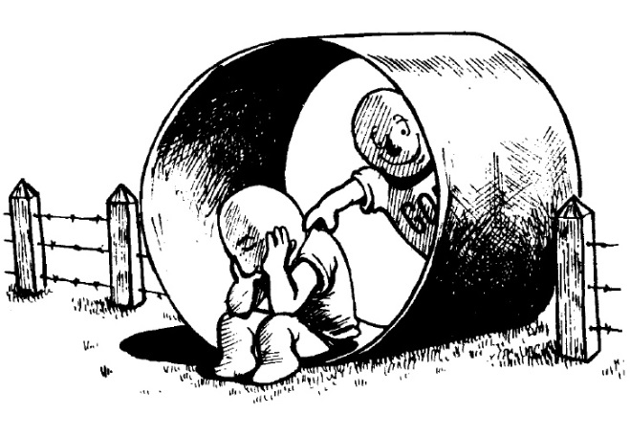

God’s offer, in Jesus, is salvation - a complete package with several parts: forgiveness of sins, a place in his family, his presence with us here and an eternal home in Heaven. This new start and new life is guaranteed to anyone who comes to Jesus and accepts him as their Lord, no matter how undeserving they may be. We can really belong to him and belong with him forever.

And there’s more - God hasn’t left us to stumble through this world ourselves as we travel toward the Heavenly destination. He has promised to be with us, indeed in us, by the gift of his Holy Spirit - his living, transforming presence in our lives.

Freely…?!

This ‘grace’ has taken all of us by surprise. Jesus described this wonderful discovery as like a person who discovers treasure buried in a field and then rushes off to sell all he has, in order to buy that field and possess the treasure. Nothing in the world can compare with the value of the gift of life in Jesus.

We are suspicious of free gifts but this is the real deal! Jesus has turned the world’s ways of thinking upside down. There are no ‘good’ and ‘bad’ people or ‘great’ and ’little’ people in the world - only human beings who have all fallen short of God’s glory. He offers to save us as his free gift, so that none of us may boast about possessing it. All God asks for is our trust (‘faith’) in him.
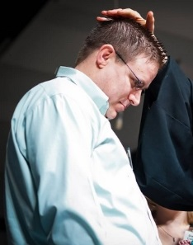
A ‘Profession of Faith’ (sometimes called ‘Confirmation’, or more loosely, ‘joining the church’) is the response of a Christian adult to God’s love and grace. If you have not been baptised before, now may be the time to make a ‘Profession of Faith’, at which point you would be baptised.

What’s sprinkled water got to do with it?

Baptism is a symbol. It’s a badge with a meaning. It’s a promise in a visible form.
Think of that water being poured gently from above. It promises:
- God will wash away our sins as if with clean water;
- God has covered over our sins in the death of Jesus;
- By believing we are covered with the life of jesus
- God pours his Holy Spirit into the lives of those who believe; and
- God pours these gifts freely from his hand.

So why baptise children?

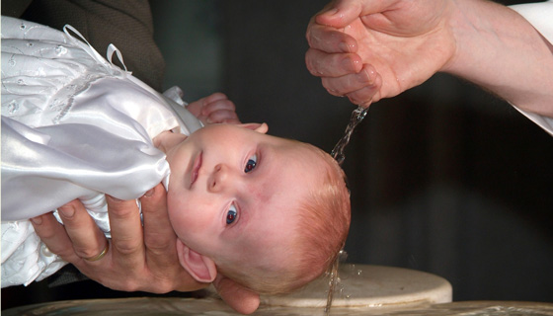
Baptism, for an adult, is like a wedding ring - a sign of permanent bond. When a child is baptised it’s a bit like putting an engagement ring on the child and saying "we parents are following Jesus and we want to bring up this child to do the same".

Obviously, babies can’t understand the significance of Baptism but we believe children are part of the family of the church. God has a special purpose for family life as the first means of nurturing faith. Baptised children will be nurtured in a home where Jesus is acknowledged as Lord. Faith is not only talked about and taught, but shown in the lives of believing parents.

In practice, parents at a Baptismal service will say ‘I do’ to two questions:
- “Do you profess your faith in God as your Heavenly Father, in Jesus Christ as your saviour and Lord, and in the Holy Spirit as your sanctifier”
- “Do you promise, in dependence on God’s grace, to teach …’Jimmy/Jeannie’… the truths and duties of the Christian faith and by prayer, instruction and example, to bring him/her up in the ways of the Lord Jesus Christ.”

In the Church of Scotland, the congregation promises to fulfil an important role. There is no equivalent to the tradition of ‘Godparents’ (although you may still give this honorary title to particular friends). Instead that is a role taken on by the congregation. When a child is baptised the congregation present in church also promise to play their part in the child's spiritual nurture. In practice, that means praying regularly for you as a family, doing anything we can to make you feel a welcome part of the church family and providing that context in which we all, adults and children, can grow into fullness of life.

How can we help you to follow Jesus?

Whether you are a parent bringing a child or an adult thinking about your spirituality, the only important question is, ‘are you following Jesus?’
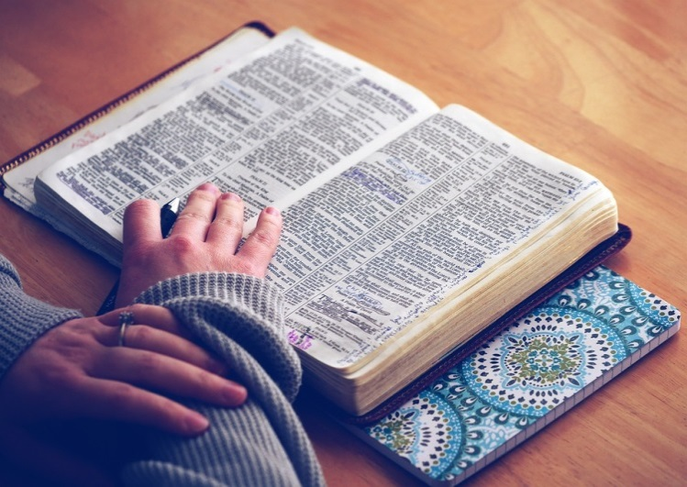
That's something you may not have thought about seriously. Talk to your Christian friends. Come along to St. David’s and begin this journey of discovery with us. There are no set seats in church you can sit anywhere and you don’t need to be a member to attend. Here in St David’s most of the congregation gather after a service for a cup of tea or coffee. It is a chance to meet with people and chat.
One excellent way to think about what it means to follow Jesus is to participate in a Christianity Explored group, which we run from time to time. That would give you an opportunity over seven weeks to read a part of the Bible, and ask as many questions as you want about who Jesus is, what difference his life, death and resurrection has made, the life he promises to those who accept him and what is involved in being a Christian disciple. Then we can think about whether you want to profess faith in Jesus.

Many people who were baptised as infants have had little contact with the church as they grew up. However, baptism is never repeated. So if you were baptised as a baby, in whatever church, you are still baptised, but you can ‘confirm’ that as an adult in the act of Profession of Faith.
If you are already a Christian and you belong to another church or denomination and you feel drawn towards joining the Church of Scotland and St. David’s in particular please speak to me about it.
Jesus offer of life in all its fullness is free and wide open to you if you chose to take that path. Baptism is something very special which even today still costs some people their lives, particularly if turning to Jesus from other religions. I would love to be able to conduct a baptism for your child. Get in touch and we can take the next step on a journey together.

Graham M. Thain
Minister

‘Sanctifier’. This is a word from the Bible meaning the one who makes us clean and changes us on the inside so that we can be the kind of people God wants us to be.

